Game Name

Published By:

Developed By:

Revision: 0.0.1

# Document History

|  |  |  |  |
| --- | --- | --- | --- |
| **Version** | **Date** | **Summary** | **Author(s)** |
| 0.0.1 | 29/05/24 | Game Summary, Game Overview, Story and Game play draft | Yuna |
| 0.0.2 | 30/05/24 | UI, First Time Exp., Assets List, CDD | Yuna |
|  |  |  |  |

Document History

Game Summary

Target Platform(s)

Business Model

Game Overview

Theme / Setting / Genre

Core Gameplay Mechanics

Server / Online Mechanics

Story and Gameplay

Story

Core Gameplay

Meta-Games

User Interface / Screens

First Time Experience

Asset List

Associated Documents

# 

# Game Summary

3D Tetris game with self-made assets.

## Target Platform(s)

* Created to play without wi-fi.
* The game will be in landscape mode.
* 3d person view from top

## Business Model

This will be a free to play game.

# Game Overview

## Theme / Setting / Genre

The game will be located on a table where a player can move around and has 2 buttons to move objects in Tetris. There will be decoration on the table such as notebooks, pencils, flowers and so on.

The theme is cute and atmosphere cozy game.

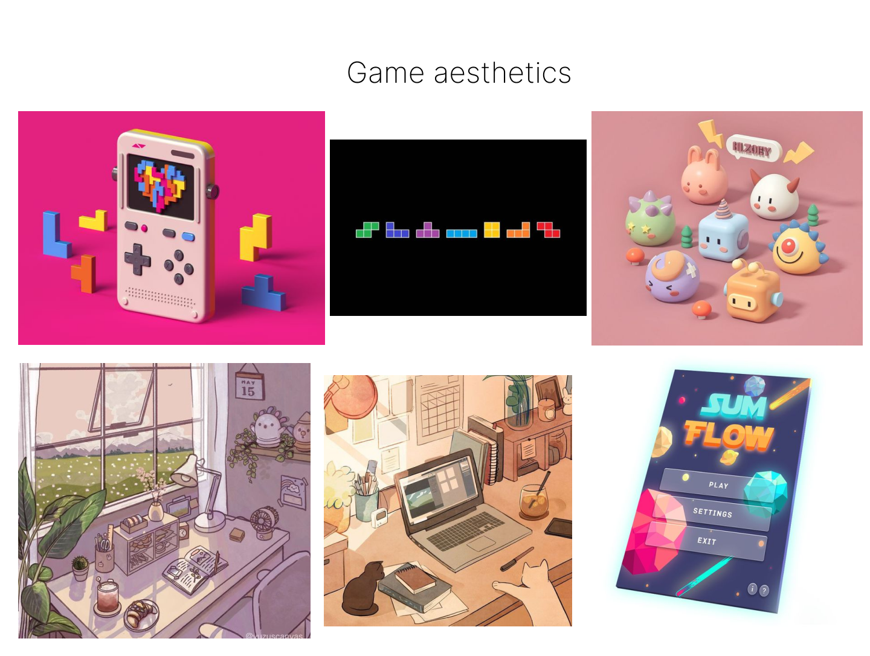

## Core Gameplay Mechanics

Point to other games that this is similar to.

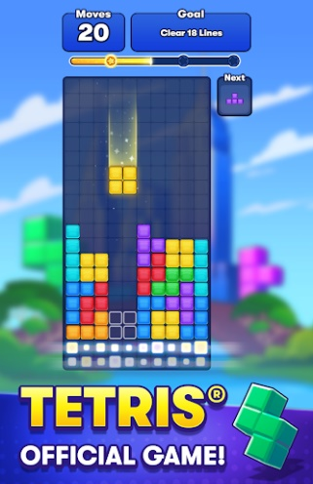 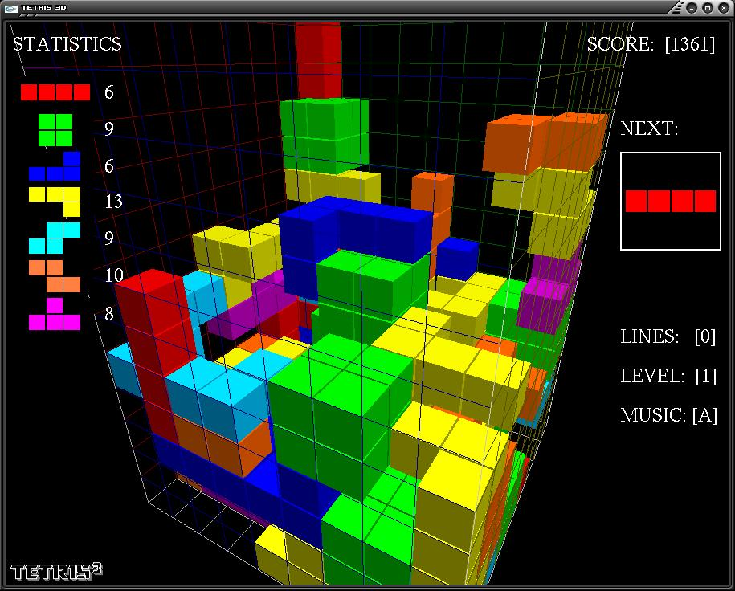

* 3d cozy and beautiful game
* Player controller
* Cute design
* Atmosphere music

## Server / Online Mechanics

Not decided

# Story and Gameplay

## Story

Everything happens in a room where small cute character moving around and playing Tetris.

## Core Gameplay

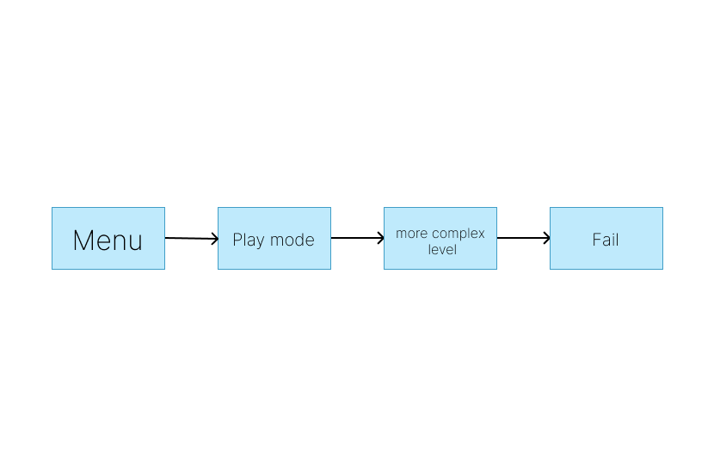

## Meta-Games

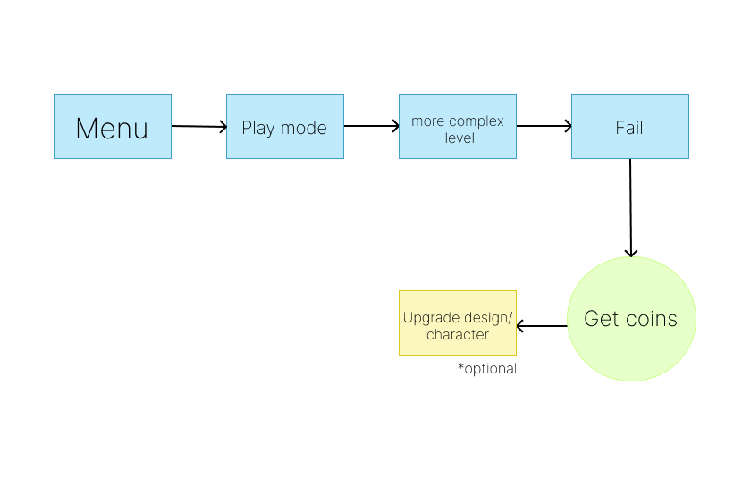

# User Interface / Screens

Wireframes of **every** screen or popup in the game and clear info on how they connect and lead to each other.

Numbering these sections makes them easy to find and you may even want to make a master flow-chart with ALL screens showing how each connects to the other.

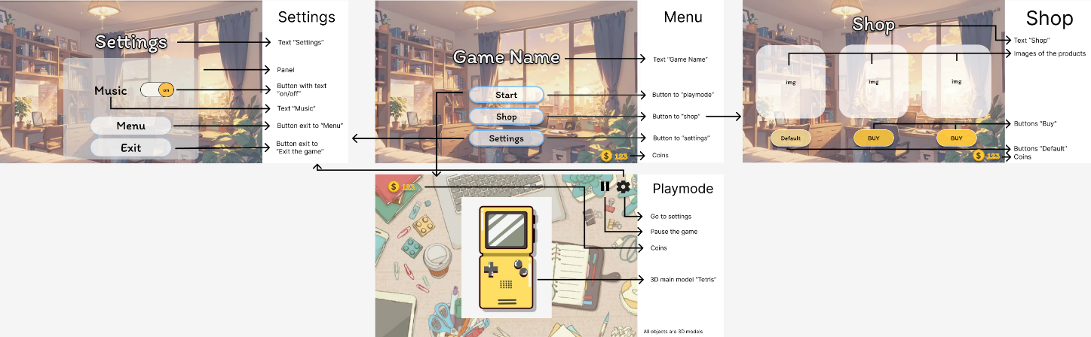

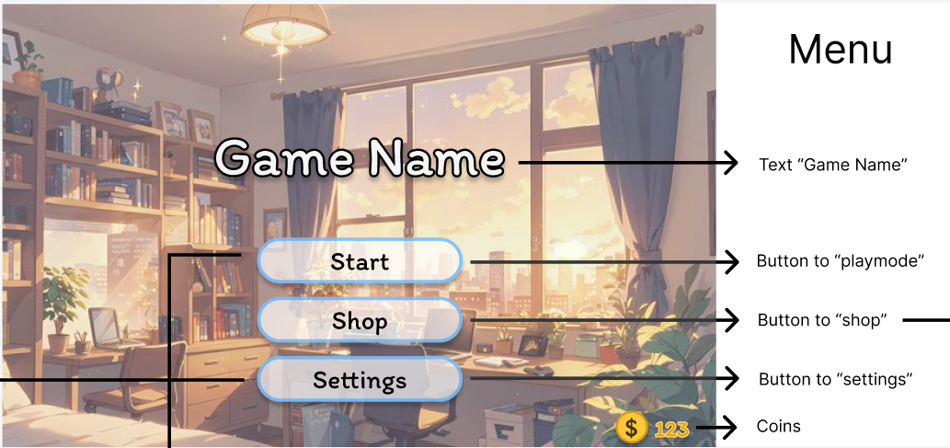

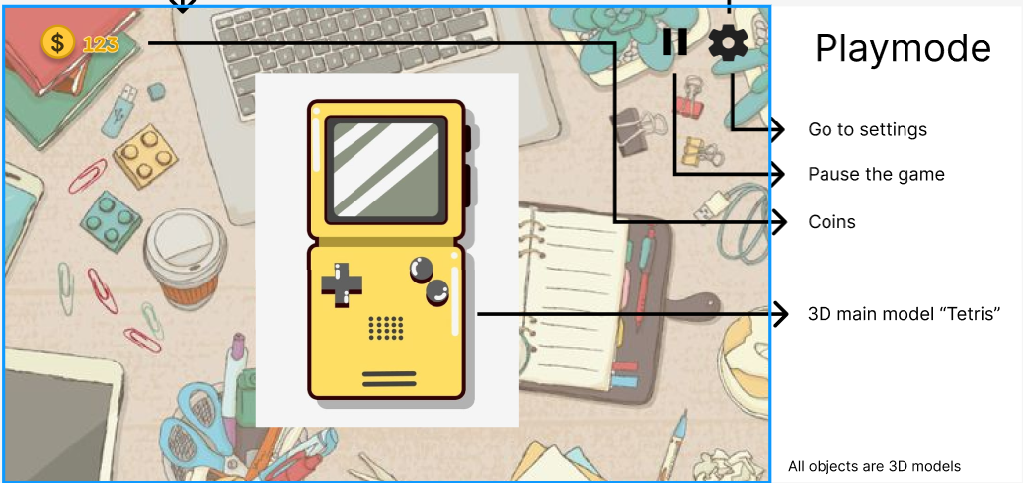

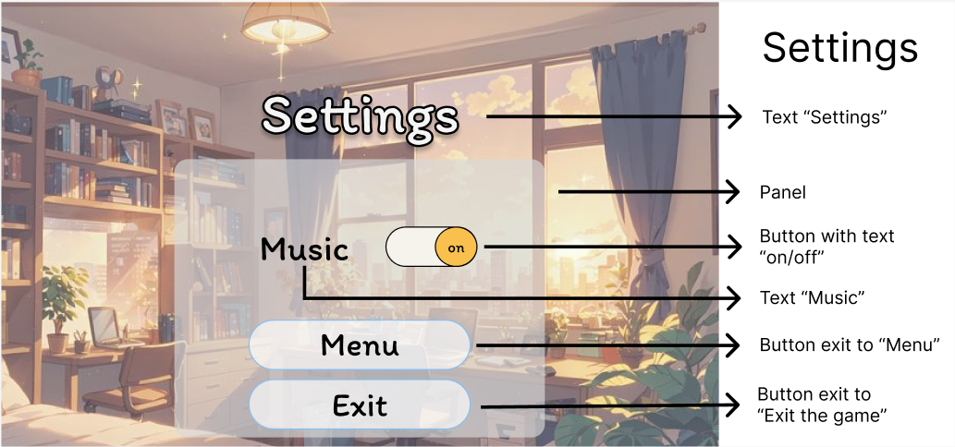

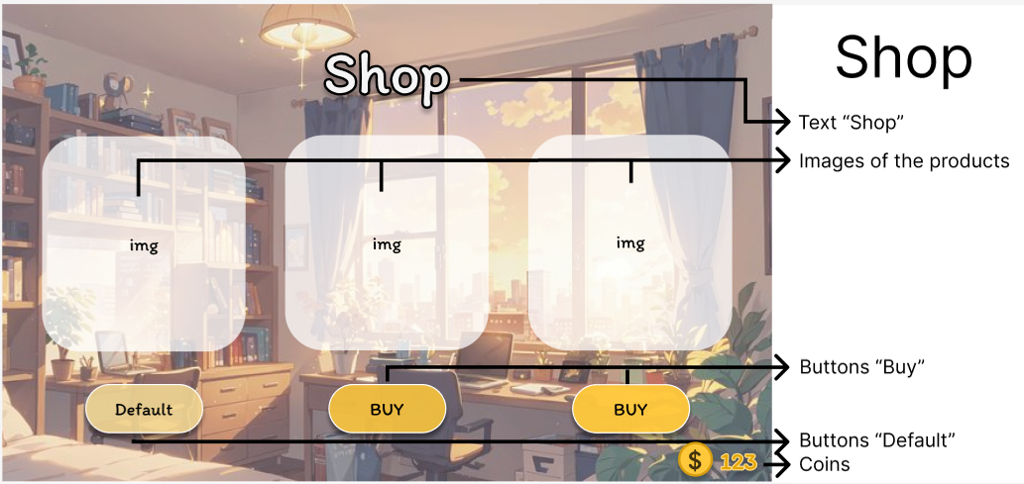

# First Time Experience

After the player presses “Play” button on the menu the player get panel with rules how to play. The panel will say that the player should step on the buttons in front of him to move Tetris pieces.

# Asset List

* Art

3D and 2D low poly models created in Maya 3D.

* Animations

Animations for the main character (Idle, Run, Jump)

* UI - Icons, Buttons, Pop Ups, Panels
* Game Objects
  + Table design
  + Characters
  + Tetris
* Particle FX

Use Assets store/internet.

* Sound Effects

Use Assets store/internet.

* Music

Use Assets store/internet.

A big spreadsheet with columns and sections for each screen / major area is helpful:

|  |  |  |
| --- | --- | --- |
| **Category** | **WORLD MAP** | **Description** |
| Full Screen | Background | Background image that covers the whole scene |
| Icon | Icon 1 | Coin |
| Icon | Icon 2 | Settings |
| Icon | Icon 3 | Pause |
| **Category** | **ENVIRONMENT ASSETS** | **Description** |
| Full Screen/3D | Table | Table where everything happens |
| 3D | Tetris | Main model where the player playing |
| 3D | Character 1 | Default character |
| 3D | Character 2 | Character with design 1 |
| 3D | Character 3 | Character with design 2 |
| 3D | Models on the table | Other decoration on the table |

# Associated Documents

* Full Asset List (Spreadsheet)
* Technical Design Document (TDD)
  + All Tools Used
  + Architecture Decisions
  + Cloud Hosting
  + Etc.
* Creative Design Document (CDD)